Your Name
Aubrey
Honors English 12
Date (written day month year)
Title
Start your essay.

Reminders:
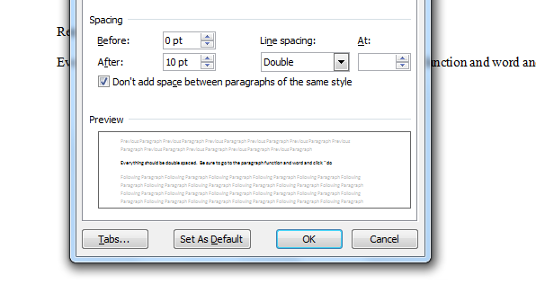
Everything should be double spaced. Be sure to go to the Paragraph function and word and click

Font should be Times New Roman size12 and black ink.
On Monday, please turn in
- Prompt
- Rough Draft
- Peer Edit
- Self- Edit
- Good Copy

The title should be one enter down from the top and centered. Then you enter down one more time, hit tab, and start writing the essay.
When you put the page number at the top, make sure you click page number from the header and footer toolbar, do not just type 1, or you will have a 1 at the top of each page.
BE SURE YOU HAVE A THESIS STATEMENT THAT ANSWERS YOUR PROMPT AND THAT YOU REFER BACK TO IT IN EACH PARAGRAPH!!!!

