Parallel Structure
Parallelism involves writing balanced sentences. Two or more ideas that are logically related should be expressed in grammatically similar constructions. In addition, similar constructions should follow each of a pair of correlative conjunctions: both/and, either/or, neither/nor, whether/or, not only/ but also.

For example, you might imagine the sentence parts hanging on a scale when you check for parallelism:
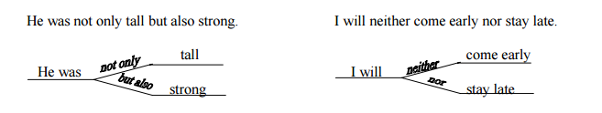

Study the following examples.
Unparallel: Last summer I learned tennis, to swim, and riding a horse.
Parallel: Last summer I learned to play tennis, swim, and ride a horse.
Last summer I learned to play tennis, to swim, and to ride a horse.
Last summer I learned tennis, swimming, and horseback riding.

Unparallel: She was not only beautiful but also a spoiled child.
Parallel: She was not only beautiful but also spoiled.
She was not only a beautiful child but also a spoiled one.

Unparallel: A math book with practice problems and having a good index is useful.
Parallel: A math book with practice problems and a good index is useful.
A math book with practice problems and with a good index is useful.
A math book having practice problems and a good index is useful. _______________________________________________________________________________________________________ Directions: Place a check by the parallel sentence in each pair.

1a.___ The employee was conscientious, devoted, and he worked hard.
1b.___ The employee was conscientious, devoted, and hard-working.

2a.___ The camp has several fields for games and swimming in the lake.
2b.___ The camp has several fields for games and a swimming area in the lake.

3a.___ Andy wanted neither the assignment at Columbus nor the job at Toledo.
3b.___ Andy wanted neither the assignment at Columbus nor to be sent to Toledo.

4a.___ Eve is an excellent tennis player, serving fast and being good at volleying.
4b.___ Eve is an excellent tennis player, having a fast serve and a good volley.
5a.___ She was both a good skier and liked to play basketball.
5b.___ She was both a good skier and a fine basketball player.

6a.___ He told me to shut up, mind my own business, and leave him alone.
6b.___ He told me to shut up, mind my own business, and to leave him alone.

Directions: Revise each of the following sentences using parallel structure.

7. Customers may climbing the stairs, ride the escalator, or taking the elevator.

8. I will meet you either at the movie or see you later at the party.

9. Jake knew he had to run or stayed to face the consequences.

10. I was told that finishing high school and to enroll in college would be wise.

11. He didn’t know whether to study first or be watching television.

12. To sleep and eating were his main occupations.

13. In the evenings we would swim in the lake and dancing afterwards.

14. Either he should do it or let me do it.

15. Her ambition was both to act in movies and writing a book about her experiences.

