Character Spotlight: Lady Macbeth 1.5
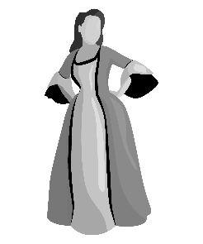
Lady Macbeth has been called the evilest woman in all of literature. Can this be true? With all of the evil characters floating around in the world of literature can one stand out among the rest? That is a question you can and must answer for yourself. Remember that your opinions about a character are based on what the author presents to you and Shakespeare absolutely paints a picture of evil when he introduces you to Lady Macbeth. Let’s go over the things that we know about Lady Macbeth in 1.5.

- She thinks her husband is too weak to act upon what he claims he will do. She says that he is “too full of the milk of human kindness” which is an idiom for compassion and caring for others. Basically, she thinks he is too soft to do what needs to be done.

- She asks the spirits to unsex her so that she can be as evil as a man. In this time period women were thought incapable of murder. It was believed that women were weak and could not do the things that men could do like fight in battles, hunt and kill animals, or kill another human. Furthermore, Lady Macbeth is a Christian and as one should not be asking spirits to unsex her. This would not have set well with Shakespeare’s audience; however, he knew exactly what he was doing. Women like Lady Macbeth were killed upon suspicion of witchcraft in his world.

- She tells her husband to leave the plans of Duncan’s murder to her AND he listens to her. When Macbeth arrives at the castle she tells him that his face is an open book and that he must learn to look innocent while being a serpent underneath. This is an allusion to the biblical story of the Garden of Eden in which the devil disguises himself as a snake in order to trick Eve. Even more important is the fact that Macbeth, a man living in a world where women have no say and no power, allows his wife to run the show. This fact speaks volumes about both of these characters.

Remember that this is just the first introduction to Lady Macbeth. She will develop as a character as the play goes on!

