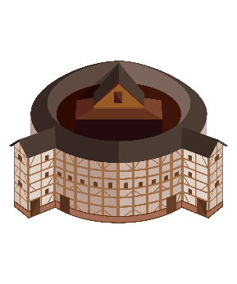
Comic Relief in Shakespeare’s Tragedies

Shakespeare often used comic relief in his tragedies. Comic relief is when a comedic incident offsets more serious events in a drama or literary work. This is needed mostly in tragedies. Tragedies are intense plays that have many extreme moments. The audience is kept entertained by these highs in action, but they cannot be continual.
The intensity is the appeal of the tragedy; however, intensity needs a break in order to be felt continuously. Think of a rollercoaster. The dips and turns would not be nearly as exciting if that was all there was to the ride. There must be times when the intensity is broken. This is where comic relief comes into play.
Comedic characters are also part of breaking up the intensity of a tragedy. There are two types of comedic characters: major and minor comedic characters. Major comedic characters are important parts of the action in a play. They are major characters whose purpose is to lighten the less intense scenes. Minor comedic characters are often only in one scene. Some tragedies have both major and minor comedic characters.
Examples:
Character | Play | Type
Nurse | Romeo and Juliet | Major
Mercutio | Romeo and Juliet | Major
Peter | Romeo and Juliet | Minor
Clown | Othello | Minor
The Porter | Macbeth | Minor

